**ZERO TOLERANCE**

**St Mary’s surgery is committed to a Zero Tolerance approach to abusive language, behaviour or actions. This includes potential or actual physical violence & verbal abuse to Doctors, Practice Staff or other persons present on the premises In the event of actual or threatened violence we reserve the right to contact the police.**

**This could result in you being removed from the Practice list & the incident will be recorded on your medical records**.

**Repeat Prescriptions**

Repeat prescriptions can be ordered in surgery, by post or fax. Our fax number is 01922 775160. Written requests can be placed in the box on reception or given directly to the receptionists.

We only take telephone requests for repeat prescriptions from housebound patients

Please do not request repeat prescriptions from the Doctor.

**Please allow 48 hours for us to prepare your prescription.**

**St Mary’s Surgery**

**Pinfold Health Centre**

**Field Road**

**Bloxwich**

**WS3 3JP**

**Tel: 01922 775151**

**Fax: 01922 775160**

Enter Contact Information Here | 1127 Lombard Blvd. San Francisco, CA 59802 | phone 555.555.5555 | fax 555.555.5555

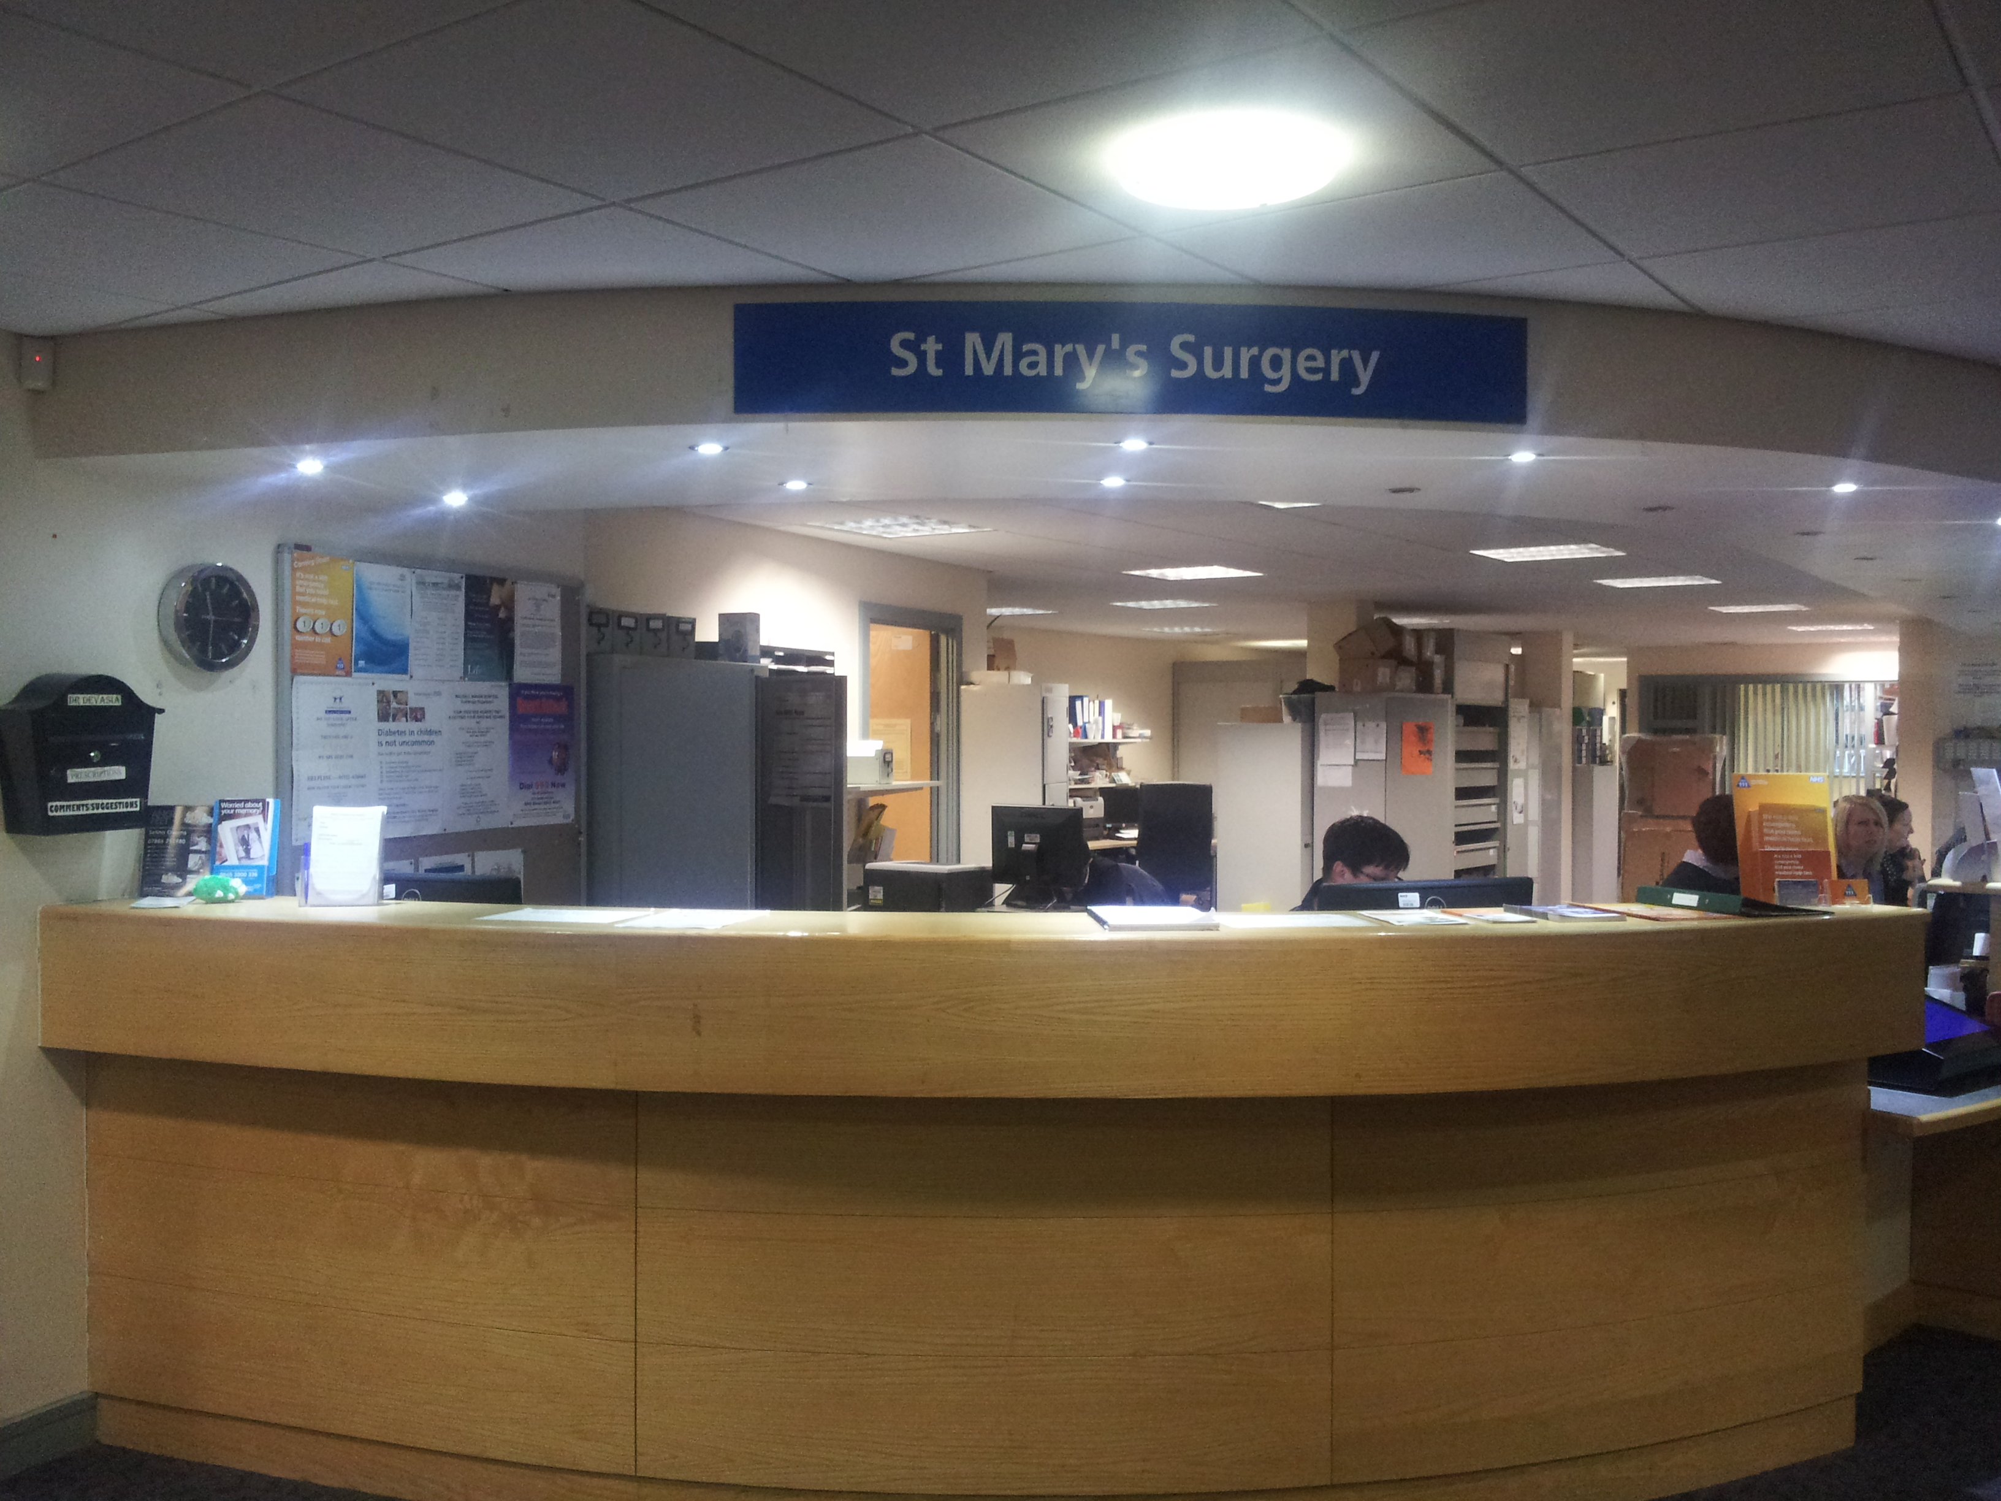

**Weekend & Night Cover**

For you need medical advice when the Surgery is closed, you can contact NHS 111 for medical information & advice.

**Patient Note**

On the last Wednesday of every month the Surgery closes at 1pm for staff training.

If need medical advice between the hours of 1pm – 6.30pm please contact WALDOC on:

01922 501999

**Confidentiality & Data Protection**

We record your personal information in order for us to provide you with the appropriate care & treatment. This information is recorded on your computer medical records. We are registered with the Information Commissioner under the Data Protection act as a data controller.

St Mary’s Surgery will ensure that patient confidentiality is maintained at all times by all members of the team.

**Complaints**

**If you have any concerns about the service or care that you receive from St Mary Surgery, please ask to speak to the Practice Manager. She will make every effort to see you immediately however this may not always be possible therefore an appointment may be made for you to speak to her within 24 hours.**

**Formal complaints must be made in writing & addressed to the Practice Manager who will then deal with your complaint in line with our Complaints Procedure.**

**We strive to give our patients & families the best service possible and we welcome any comments or suggestions. There is a box on Reception for you to put any comments/suggestions in writing.**

**Dr. D. Panagamuwa**

**&**

**Dr. N. Devasia**

**Dr. D. Panagamuwa**

**&**

**Dr. N. Devasia**

**Our Doctors**

**Dr. D. Panagamuwa (Male)**

MBBS, MRCGPDFSH

**Dr. N. Devasia** **(Male)**

Bsc.MBBS.Dip.Ob. LRCP. LRCS. MRCOG

**Additional GP’s**

**Dr. M. Wijetunge** **(Female)**

MBBS, MRCGP, DRCOG, DFSH

**Welcome to St Mary’s Surgery**

St Mary’s Surgery is based within Pinfold Health Centre, a purpose built health centre constructed in 2004. Pinfold offers easy access for the disabled.

The Practice area covers the Bloxwich & surrounding areas.

**Surgery Times**

***Dr. D. Panagamuwa***

Monday - 09.30am – 11.30am

- 17.00pm – 19.00pm

Tuesday - 8.30am – 11.30am

- 16.00pm – 18.00pm

Wednesday - 08.30am – 11.30am

16.00pm – 18.00pm

Thursday - 16.00pm – 18.00pm

***Dr. N. Devasia***

Monday - 08.00am – 10.00am

Tuesday - 07.30am – 10.00am

Wednesday - 08.00am – 10.00am

***Dr. M. Wijentunge***

Thursday - 08.30am – 11.30am

Friday - 08.30am – 11.30am

**HOME VISIT REQUESTS MUST BE MADE BEFORE 11AM**

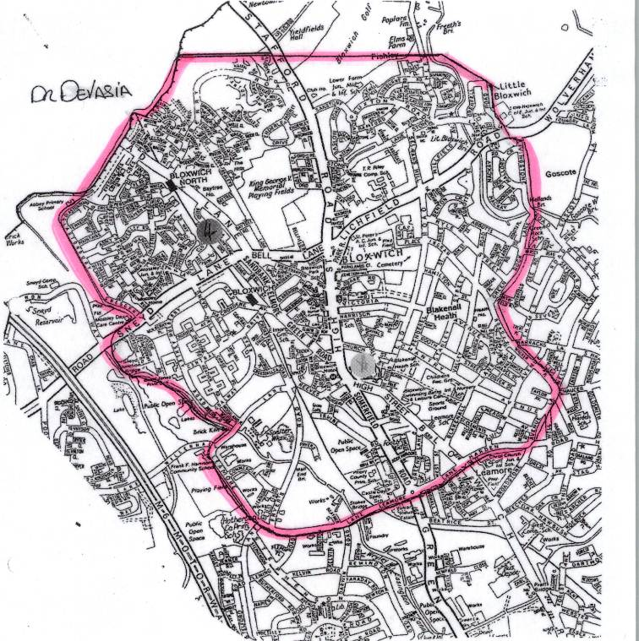

**How to register as a Patient with St Mary’s Surgery**

If you would like to register as a patient with St Mary’s we will first ask your current address, if you are within our Practice boundary we will then ask you to complete a registration form, health questionnaire & Summary Care Records (SCR) opt out form (if you do not want your medical information uploaded to SCR). Everyone over the age of 16 years old will then need to book in with one of our Practice Nurses for a new patient check. This will be a 20 minute appointment where our Nurses will undergo a brief health check with you, you will also be required to bring a urine specimen with you.

**Our Team**

***Practice Manager***

Stacey Wyatt

**The Practice Manager is responsible for the general running of the Practice & will be able to help with any non-medical queries that you may have.**

***Reception/Administrators***

Charisse Hawkins

Carole Richards

Natalie Morris

Claire Williams

**Our Receptionists are responsible for taking your phone calls, making your appointments & process your repeat prescription requests. They will ensure your enquires are dealt with as efficiently as possible whilst respecting your confidentiality.**

***Secretary***

Donna Hinks

**Our Secretary deals with patient referrals to Hospitals & is the main contact for Choose & Book queries.**

***Nurses***

Carol Dwyer – Nurse Practitioner

**Our Practice Nurses see patients by booked appointments. They are here to monitor your medical conditions such as Diabetes, Asthma, Heart disease & COPD. They also offer regular reviews of those with Hypertension, contraception & can offer advice on numerous health related topics.**