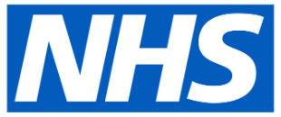
Access to NHS Dentistry is currently limited during the pandemic as all dentists have been asked to stop all routine “face-to-face” dental care.
However, if you need urgent dental care, help is at hand:

CALL your dental practice:

They will give you advice over the telephone and make arrangements for you if you need to be seen.

If you don’t have a dentist, find your nearest dentist and CALL them. You can search for your nearest dentist at: https://www.nhs.uk/service-search/find-a-dentist

You can also contact NHS 111:

You can ask for a translator if you need one.

NHS 111 is available 24 hours a day, 7 days a week

If you’re deaf, you can:
- use the NHS 111 British Sign Language service: interpreternow.co.uk/nhs111
or
- call 18001 111 on a textphone

Do not worry if you have COVID-19 symptoms, appropriate arrangements can be made to see you if you need urgent dental care.

